Help Ahead (formerly MHTO) Fax Number: (647) 689-7582
1-866-585-6486 Email: helpahead@stridestoronto.ca

Please be informed that all referrals require the involvement of the legal guardian(s).
Your patient should continue under your care for their Mental Health concerns until their assessment takes place. If a crisis situation arises, please inform them to go to their closest Emergency Department.

PLEASE COMPLETE THIS 3 PAGE FORM IN FULL BEFORE FAXING

Referral Date _______/ _______/ _______________

Patient Information
Last Name  Click or tap here to enter text. |  | Given Name  Click or tap here to enter text. |  | Date of Birth  Click or tap to enter a date. |  |  |  | Preferred Name / Pronoun/s  Click or tap here to enter text.
Health Card Number
Click or tap here to enter text.
Address:Click or tap here to enter text. |  |  | Apt#:  # |  | City:  Click or tap here to enter text. |  |  |  | Province:  E.g. ON |  | Postal Code:  Click or tap here to enter text.
Has internet /technology access for Virtual Care  YES ☐ / NO ☐ |  | Phone Number:# |  |  |  |  | Email Address:Click or tap here to enter text.
 |  | Consent to leave voicemail with patient  YES ☐ / NO ☐ |  |  |  |  | Consent to email patient  YES ☐ / NO ☐
Primary Language Spoken  Click or tap here to enter text. | Preferred Language  Click or tap here to enter text. |  |  | Interpreter Required  YES ☐ / NO ☐ |  |  |  |  |  | Accessibility Concerns  YES ☐ / NO ☐
Parent/Caregiver/Legal Guardian Information
Parent/Caregiver/Legal Guardian Name:  Click or tap here to enter text. |  |  |  |  |  | Relationship to patient:  Click or tap here to enter text.
Phone #  # |  |  |  |  |  | Email:  Click or tap here to enter text.
Contact notified of the referral:
YES ☐ / NO ☐
Consent to leave a voicemail:  YES ☐ / NO ☐ |  | Consent to email:  YES ☐ / NO ☐ |  |  |  | Legal guardian(s) agree to be referred to a partner hospital with a shorter waitlist if applicable:  YES ☐ / NO ☐

Reason for Referral / Goals for Treatment:

Click or tap here to enter text.

Page 1

Patient Medical Information
Safety and other Specific Concerns | Past | Present |  | Mental Health Condition | Past | Present |  | Mental Health Involvement | Past | Present
Suicidal Ideation | ☐ | ☐ |  | Depression | ☐ | ☐ |  | Other Hospital Service(s) | ☐ | ☐
Suicide Attempts | ☐ | ☐ |  | Anxiety | ☐ | ☐ |  | Community Mental Health Agency | ☐ | ☐
Self-Harm | ☐ | ☐ |  | Bipolar Disorder | ☐ | ☐ |  | Therapist/ Counsellor | ☐ | ☐
Homicidal Ideation | ☐ | ☐ |  | Psychosis | ☐ | ☐ |  | Psychiatrist | ☐ | ☐
Violence Towards Others | ☐ | ☐ |  | ADHD | ☐ | ☐ |  | Developmental Concerns | Past | Present
Destruction of Property | ☐ | ☐ |  | PTSD | ☐ | ☐ |  | Autism Spectrum Disorder | ☐ | ☐
Fire Setting | ☐ | ☐ |  | Personality Disorder | ☐ | ☐ |  | Intellectual Disability | ☐ | ☐
Running Away | ☐ | ☐ |  | Eating Disorder | ☐ | ☐ |  | Learning Disorders | ☐ | ☐
Substance Use | ☐ | ☐ |  | Family History | Past | Present |  | Fetal Alcohol Spectrum Disorder | ☐ | ☐
Child Welfare Involvement | ☐ | ☐ |  | Mental Health History | ☐ | ☐ |  | Other | ☐ | ☐
Legal Charges | ☐ | ☐ |  | Family Stressors | ☐ | ☐
Custody and Access Issues | ☐ | ☐ |  | Barriers to Accessing Care | ☐ | ☐

☐I am aware that Help Ahead (HATO) provides navigational support and may connect the patient to a community child/youth mental health agency, or other suitable supports

☐I am aware that psychiatric consultation does not involve ongoing treatment and that the primary care physician is expected to remain involved with this individual’s mental health care

☐I am aware that this psychiatric consultation is not for the purpose of forensic assessment and/or custody and access.

Referrer Information
(Referring Doctor)  Click or tap here to enter text. | Address  Click or tap here to enter text. |  | City/Province  Click or tap here to enter text.
Postal Code  Click or tap here to enter text. | Phone  # | Fax  # |  | Referral being made by patient’s primary care provider  YES ☐ / NO ☐

Page 2
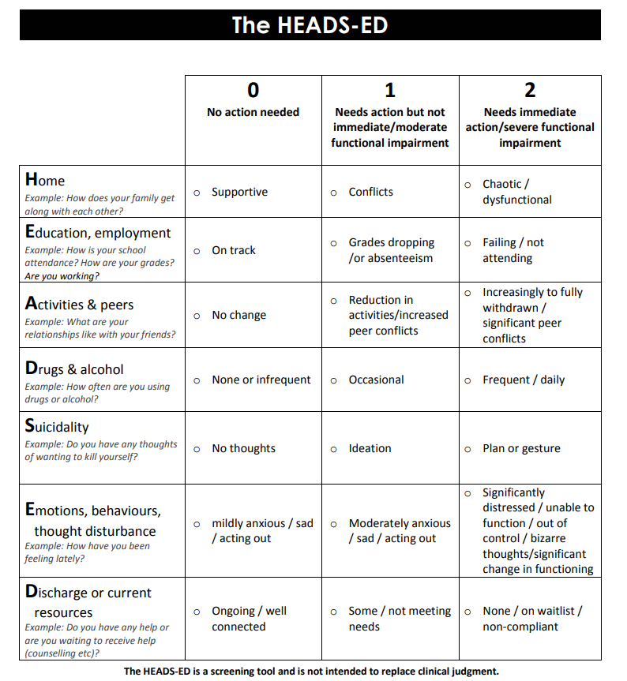

The following page contains the HEADS-ED. Please use this form to generate the scores required on page 4.

Page 3

THE HEADS-ED:
1. Date HEADS-ED completed: | _______ / ____ / ____  ☐ Date not noted
2. HEADS-ED scores:
Home: | ☐ 0 ☐ 1 ☐ 2
Education, Employment: | ☐ 0 ☐ 1 ☐ 2
Activities and Peers: | ☐ 0 ☐ 1 ☐ 2
Drugs and Alcohol: | ☐ 0 ☐ 1 ☐ 2
Suicidality: | ☐ 0 ☐ 1 ☐ 2
Emotions, Behaviours, Thought Disturbance: | ☐ 0 ☐ 1 ☐ 2
Discharge or current resources: | ☐ 0 ☐ 1 ☐ 2

3. Total sum score (out of 14): Enter Score
4. Mental health agency will initiate follow-up contact with:
☐ Youth ☐ Caregiver; relationship Click or tap here to enter text.
5. Patient and/or Parent/Guardian consents to being contacted
for a satisfaction survey of services received: YES ☐ / NO ☐

For urgent but non-emergent concerns, please contact Help Ahead directly at 1-866-585-6486 or email
helpahead@stridestoronto.ca

Please consider signing up for Ocean e-referral, to submit patient referrals directly from your electronic health record, with access to up-to-date specialist and program directories. More information can be found at:

https://www.cognisantmd.com/ocean-ereferrals/

